15.64: a) , d)

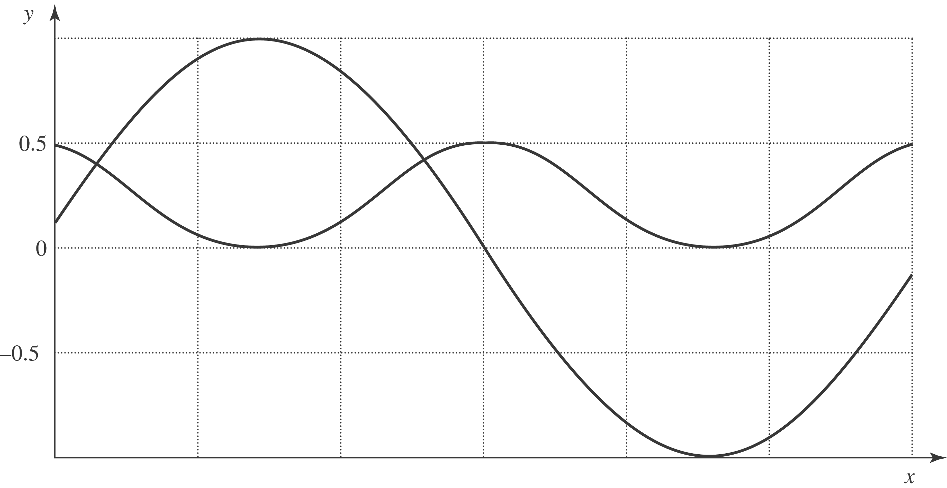
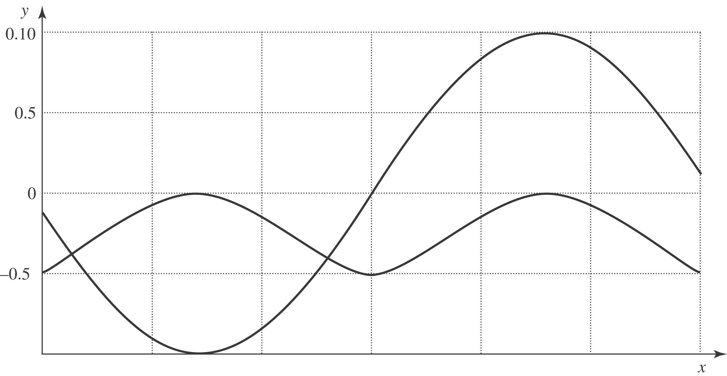

b)The power is a maximum where the displacement is zero, and the power is a minimum of zero when the magnitude of the displacement is a maximum. c) The direction of the energy flow is always in the same direction. d) In this case, 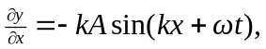and so Eq. (15.22) becomes

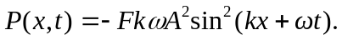

The power is now negative (energy flows in the -direction), but the qualitative relations of part (b) are unchanged.

